

**Advanced Database Systems**

**15CSIS22**

**Police Patrol System**

**Final Report**

**Submitted by**

|  |  |
| --- | --- |
| **Group Members** | **ID** |
| Lobna Hesham | 120431 |
| Mohab AbuGabal | 117276 |
| Ramy Mamdouh | 118371 |

**Supervised by**

Dr. Doaa El Zanfaly

**And**

Ms.Sarah Amer

Ms.Nada Hassan

Ms.Dahab

|  |  |
| --- | --- |
| **Table of Content** | |
| **Title** | **Page Number** |
| **System overview** | **3** |
| **Police Patrol System** | **3** |
| **System Functionality** | **3** |
| **Assumptions** | **4** |
| **EERD** | **4** |
| **EERD Detailed Description** | **5** |
| **Mapping from EERD to Class Diagram** | **5** |
| **Class Diagram** | **6** |
| **ODL(Object Definition Language)** | **6** |
| **OML(Object Manipulation Diagram )** | **11** |
| **Related Projects** | **11** |
| **Tracking** | **12** |
| **Reference** | **12** |

**System Overview**

To ensure instant response Police patrol systems enables effective communication between stationary and patrol officers. The system improves the operational efficiency, time, and cost during PM (Police Notes), providing better services to local community. Chief Dan Islom believes the system helps reduce response times by allowing dispatchers the ability to accurately determine location cases that has been reported by con (LandAirSea, n.d.). Moreover, the system identifies which police patrol is closest to a crime scene therefore get to the scene sooner.

**Police Patrol System**

The police patrol system shall be implemented using object oriented database to avert defects of the previously illustrated example. Police patrol system consists of three main actors; in which all will be stored in the database. The authorities which are either stationary police officers; responsible of receiving criminal police notes, or patrol cops escalated around the city. While the third actor is the complainant who requests for emergency assistance. When a complainant reports a certain crime or asks for emergency assistance the case is stored in the database. The crime’s geographical location scene is also detected based on its longitude and latitude (X and Y coordinate). Stationary officers are then expected to check the nearest patrol location based on the scene’s region. The assigned patrol will then be notified about the case and exact location.

**System Functionalities**

1. Complainant report the police stationary with detailed description of the crime associated with their location.
2. Officers then a fill police note from complainants who are asking for instant help.
3. Assign different crime cases to different patrols through the help of stationary police officers.
4. Locate the geographical location of the closest patrol compared to the crime scene location.
5. Assign the nearest patrol to go to the crime scene and solve the case
6. Track patrols and Crime location
7. Store officer, patrol and case information that corresponds to each crime.

**Assumptions**

1. One Shift can include more than one Police (Officer and Patrol) but one Police cannot work in more than one Shift.
2. Risk Degree is an integer which represent how dangerous and critical is the incident (ranges from 1 to 5), 5 is considered to be the most dangerous.

**EERD**

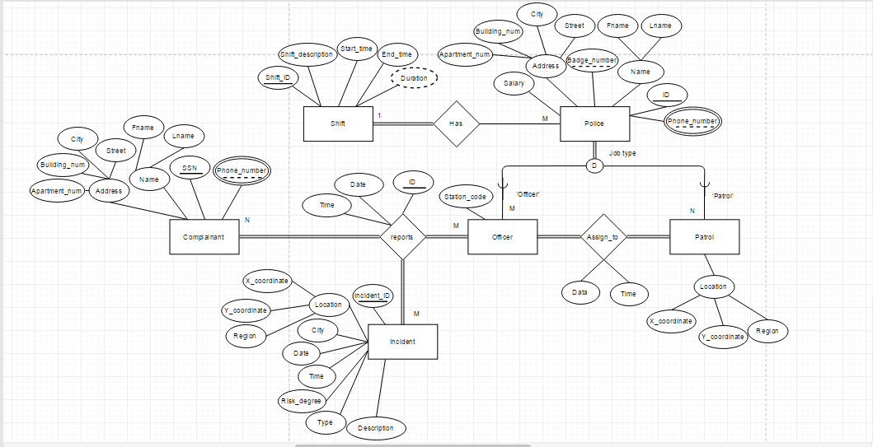

**EERD Detailed Description**

1. The Report relationship is created using entities of Complainant, Officer, and Incident.
2. The Officer and Patrol entities are sub-classes that inherent from the super-class Police. The super-class (Police) has a disjointness constraint, for either Officer or Patrol entities.
3. All attributes in the EERD are mandatory.
4. Complainant can create more than one report.
5. Officer can handle more than one report.
6. Incidents can be included in more than one report.
7. Assign to relationship is responsible to locate the geographical location of the closest patrol compared to the crime scene location.

**Mapping from EERD to Class Diagram**

1. Name, Address, and Location classes are types that will further be objects used in classes (Complainant, Incident, and Police).
2. The Incident entity is filled using objects that is already instantiated from the Complainant Class.

**Class Diagram**

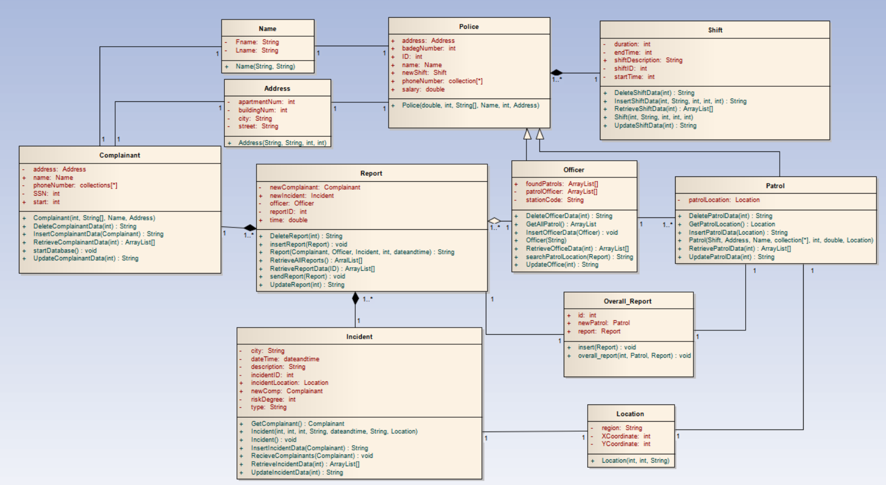

**ODL (Object Definition Language)**

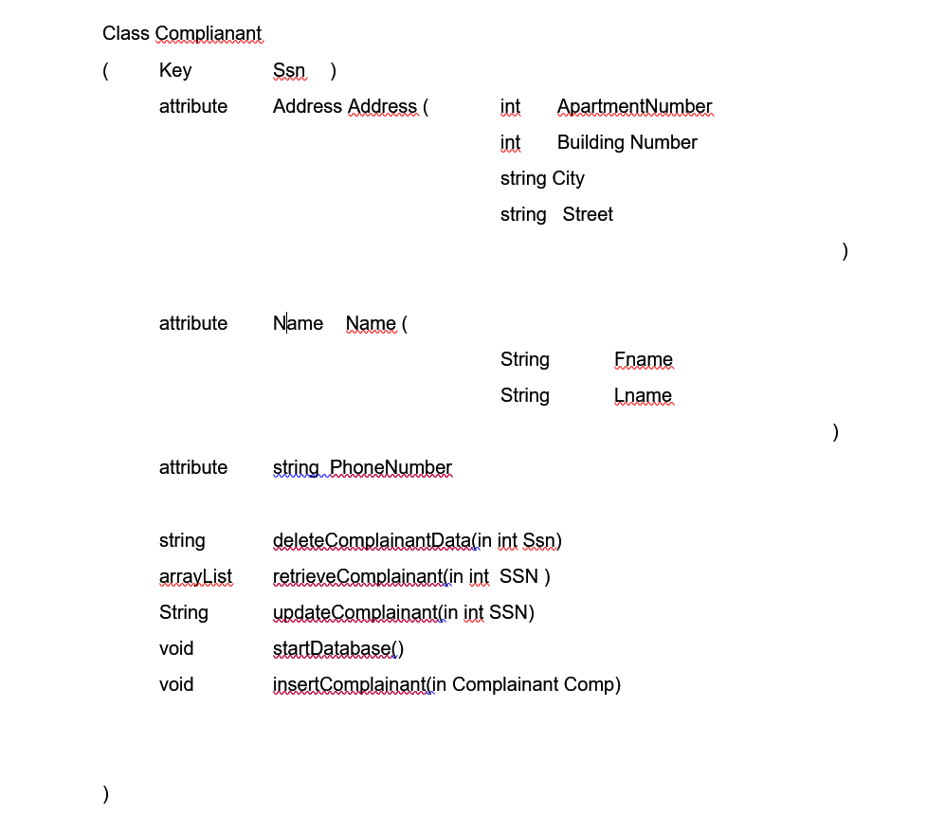

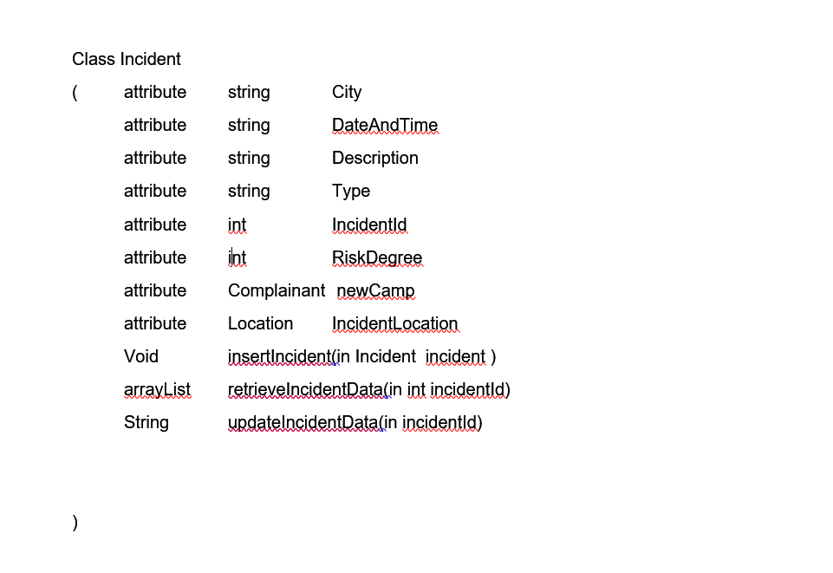

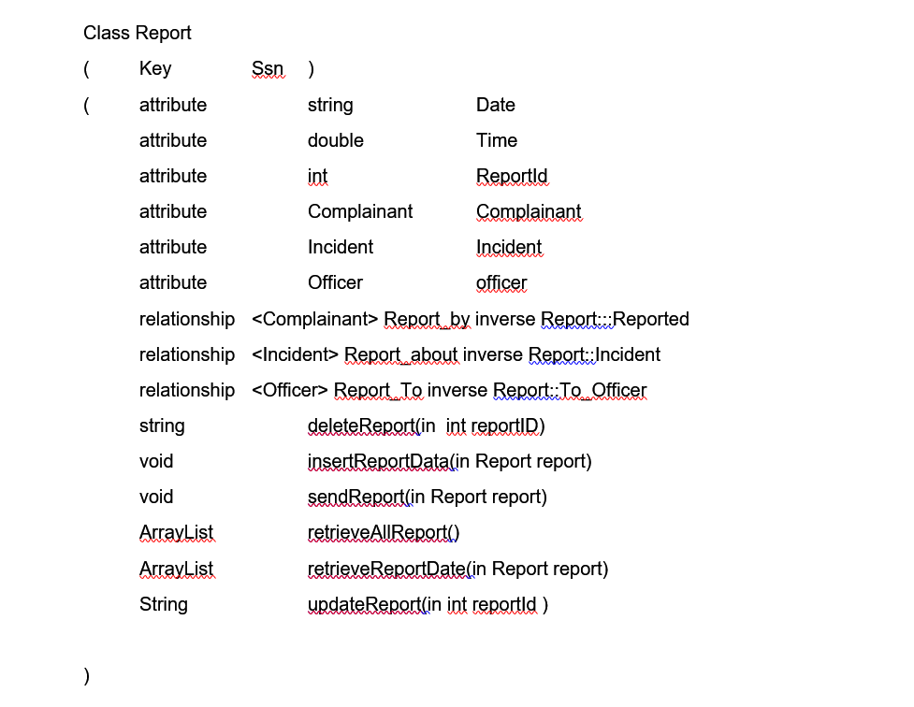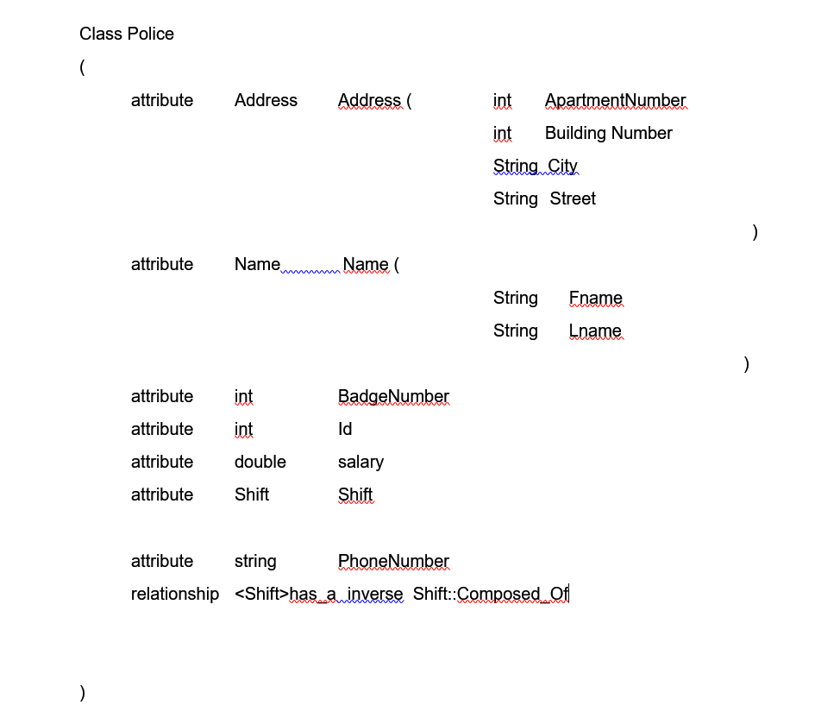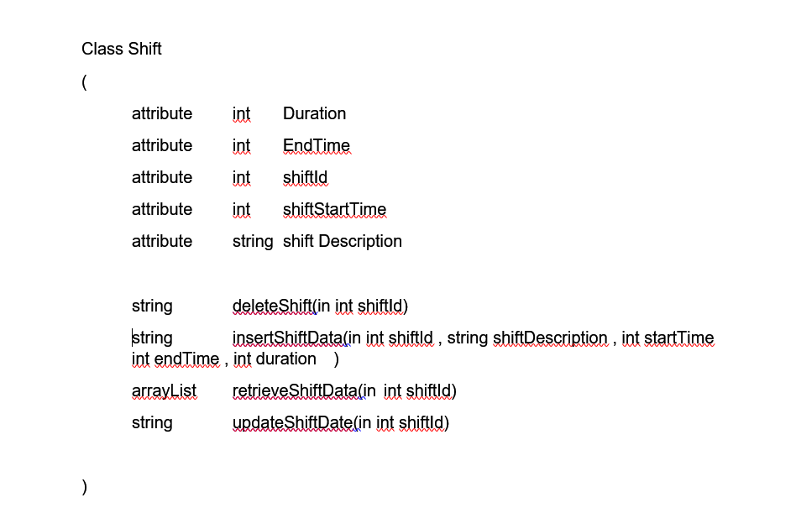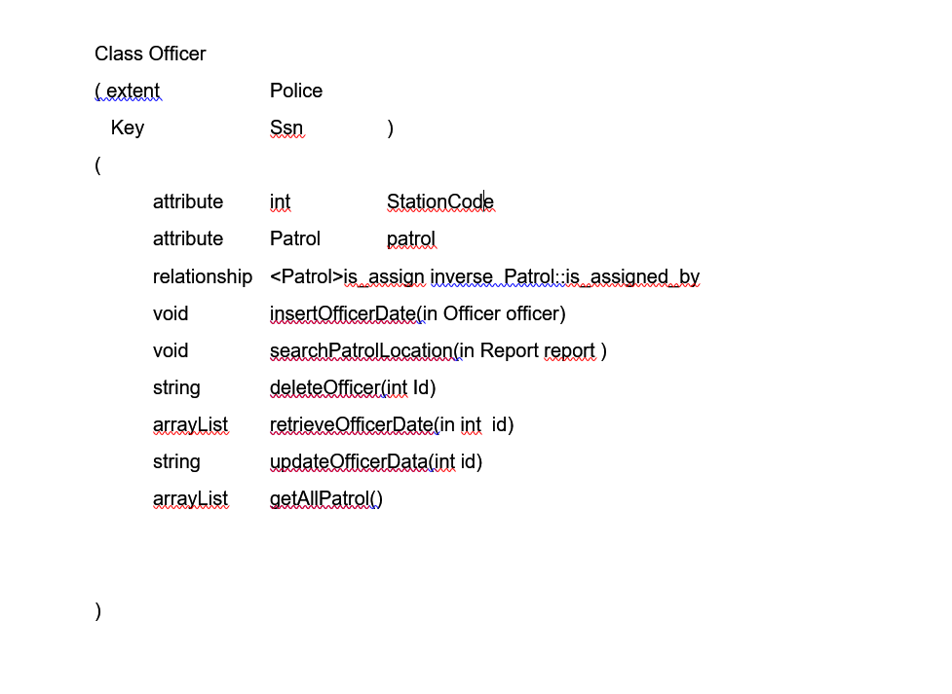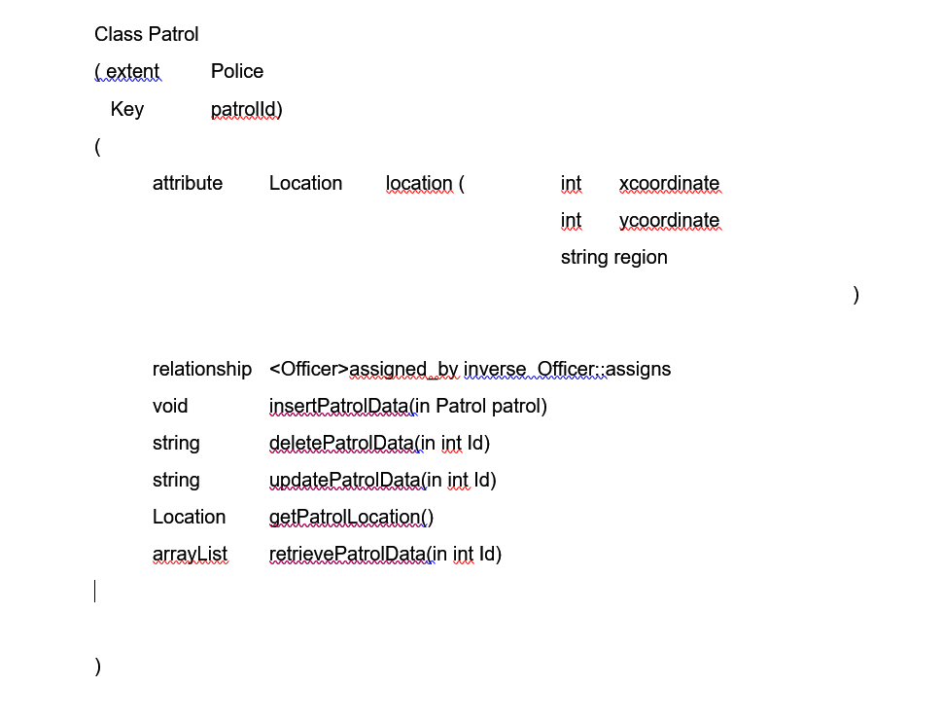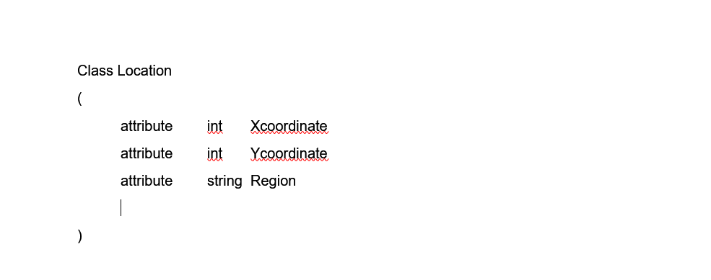

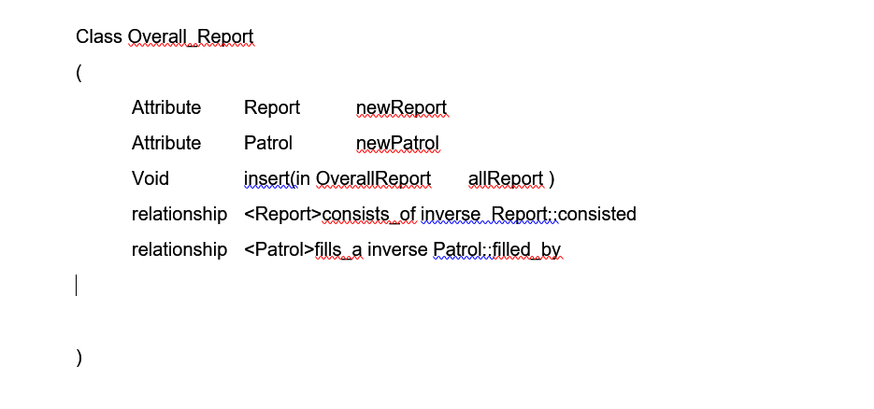

**OML (Object Manipulation Language)**

* System receives incident(s) “Complainant inserts incident date”
* Created incident is received by Officer
* Officer searches for Patrol forces in the incident’s region
* Send the incident data to patrol
* Officer then tracks the assigned patrol for each incident
* When patrol arrives a message is received in the track patrol form

**Incident object flow**

* **An incident object is created by a complainant**
* **Incident data is retrieved by the Report**
* **Incident object is then sent to the Officer**
* **Incident’s object data (location and description) is then received by the patrol**
* **After the incident case is ceased, its data is inserted in the overall report**

**Related project**

Traditional GPS and tracking devices have been costly because they consisted mainly on hardware. Due to the evolve of technology and the availability of GPS and sensor devices tracking has been much more affordable.

A similar project was implemented in (x). The project was concerned with allocating moving vehicles, tracking them and eventually inserting the information to a database. By using the tracking GPS technique, the system generally sends coordinates of the vehicle’s location to a certain modem using a SIM card. IntelliTrac Wizard is used to send vehicles coordinates, at some interval, to a GSM modem. These coordinates are then used to allocate the objects using Google maps API.

Moreover, the project’s domain required some information that must be stored in a database. Microsoft Access Database was used to implement these relational entities. Thus, the records of the vehicle’s location are regularly modified to compromise with the latest spotted location. As a consequence, Access Database had shortcomings because of the often modification that is required for its attributes. Object Oriented Database was more suitable due to the domain requirements and the frequently adjusted vehicle’s location. Using OODB data would have been presented in a form of objects resulting in enhanced changing state and more feasible programming functionalities. Unlike relational database that consists merely of rows and columns organized relational-based.

**Tracking**

Tracking systems are basically the monitoring of objects or persons, through active or passive motions. GPS or Global Positioning System tracking uses latitude and longitude coordinates to allocate objects. Medium Earth Orbit satellites transmit microwave signals that enables GPS receiver to determine a certain location and its motion precisely (Bernards, 2014).

**References**

Bernards. (2014, September 14). *interdigital* . Retrieved from Stanford telecom: http://www.interdigital.com/tracking/solution

LandAirSea. (n.d.). *Install GPS Tracking Systems on Police Patrol Cars*. Retrieved from Land Air sear: https://www.landairsea.com/gps-tracking-news/st-louis-to-install-gps-tracking-systems-on-police-patrol-cars

LOONG, C. C. (2013). *BUS TRACKING SYSTEM.* Perak.

**End of Document**